**Developing a webservices**

Download source code from <https://github.com/tsawler/bookings-udemy/releases/tag/v21>

Unzipp into you workspace

Go to visual studio

File>openfolder

Go to main directory

Run the command go run main.go

It will run the application on your browser

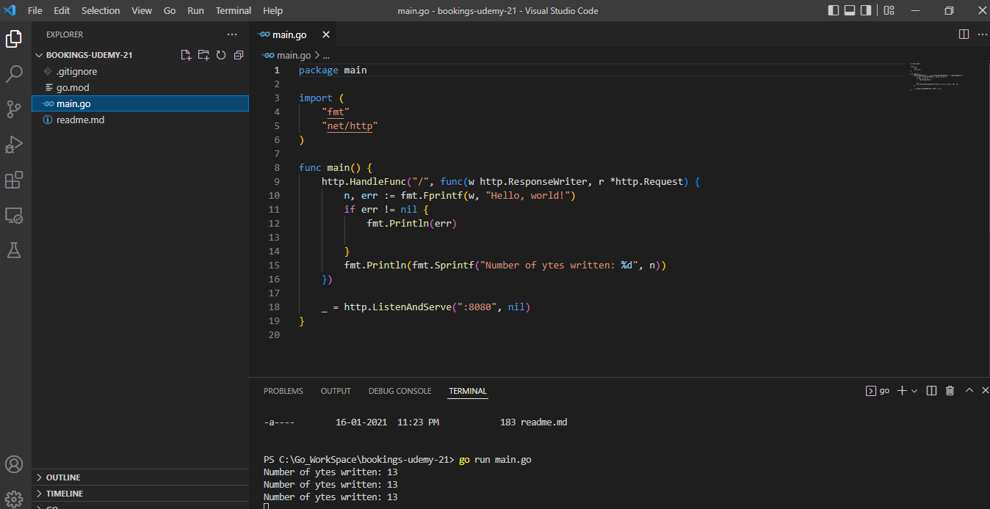

Open your browser and type URL

http://localhost:8080/

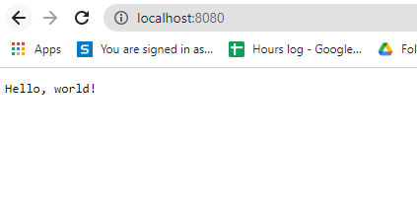

And you got a Hello World! on the browser